¡Bienvenidos a la clase de español!
Columbia High School 2015-2016 Señorita Mouw rmouw@nsd131.org
*Si tenga cualquier pregunta comuníquese conmigo por correo electrónico, después de la clase o la escuela.

Spanish II is an intermediate class stressing basic language skills and acquisition. The method we will be using is called Teaching Proficiency through Reading and Storytelling, TPRS®. Be prepared to listen, read, write, speak, sing, dance, and act in Spanish to learn the language effectively! In addition, we will be studying the Spanish culture, reading short stories and news articles, as well as giving you as many opportunities as possible to speak and write in Spanish.

Materias:
1) A 3-ring binder notebook with a pocket
- Notebook dividers (5)
2) College ruled paper
3) Pencils, Red pen, highlighter
4) 3x5 index cards spiral bound.

The following categories will determine your quarter grade. Your semester grade will be weighted at 25% for quarter 1, 25% for quarter 2, and 50% for the final.

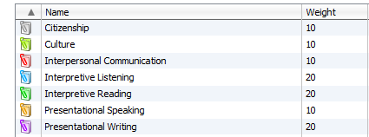

*It is your responsibility to find out what you missed if you are absent.

*It is your responsibility to keep your cuaderno organized and file each day’s activity as this will constitute a portion of your grade. Daily activities will help support the skills and vocabulary we are learning in class. They will vary between reading, writing, culture, and speaking activities.

Our Spanish Website: www.columbiaspanish.weebly.com

